# CS 340 PROJECT TWO: README

## About the Project/Project Title

Grazioso Salvare is an innovative international rescue-animal training company. They have reached an agreement with a non-profit agency, the Austin Animal Center, based out of Austin Texas, who operate five animal shelters in the region surrounding Austin. The purpose of this web application is to aggregate and maintain data provided by Austin Animal Center and provide it to Grazioso Salvare with an easy-to-use interface that enables Grazioso Salvare to more easily identify candidates that meet the specifications for generally good rescue animals.

## Motivation

Us at Global Rain believe in the missions of both Grazioso Salvare and Austin Animal Center. Rescue animals provide a pivotal role in the rescuing of people, and even other animals that find themselves in harrowing situations. Our motivation in creating and maintaining this project is to provide the necessary assistance to Grazioso Salvare in more easily searching out great candidates for the role of rescue animal. We understand that there are some breeds more suited to certain situations and providing a platform for Grazioso Salvare to identify the breeds and ages they are seeking in a user-friendly software environment only serves to progress their mission in a more equitable and efficient manner.

## Usage

The Animal Shelter project allows the user to insert new data quickly and easily into their database along with the functionality of being able to print that data to the console later. Along with being able to create and read data, the Python module, allows the user to update and delete data based upon specific queries. This is all made possible by a driver called Pymongo that enables communication between Python and MongoDB. It is the recommended method of enabling communication between the two.

**Tools Used in this Project**

The development of this project utilized several tools. MongoDB was used for its simple and straightforward setup, along with its Python-friendly syntax. MongoDB can be run locally on your own machine or can be used as a cloud service. The database can be found at <https://www.mongodb.com>. Dash was used in the development of this project, as well. This is the service that enabled the dashboard functionality of the program. Dash is a Python library that provides point-and-click functionality to data models that are responsive and straightforward to implement and use. Dash can be located at <https://dash.plotly.com>. Pandas was used in the development of this project, as well. It is a tool for Python that creates the data frames necessary for the application. More information can be found at <https://pandas.pydata.org/>.

**Usage**

The Animal Shelter program has three main functions. At the top of the web application, you will find four radio buttons: “Water Rescue”, “Mountain/Wilderness Rescue”, “Disaster Rescue/Individual Tracking”, and “Reset – Returns unfiltered state”. Using the data provided in the module seven quiz, I included the specific breeds with their preferred sexual characteristics and ages for each of the different types of rescue missions. The reset radio button simply reverts the table back to its unfiltered state. Below the radio buttons you will see a table with all the available animals. Below that are the pie chart that gives a quick visual representation of the breeds available for each of the rescue missions. Beside that is an interactive map that can be dynamically updated. When a row in the table is selected, the map will provide a marker where that particular animal is found. If you click on that marker, you can get name, breed, sex, etc. The map can handle up to five selections at once.

**Screenshots**

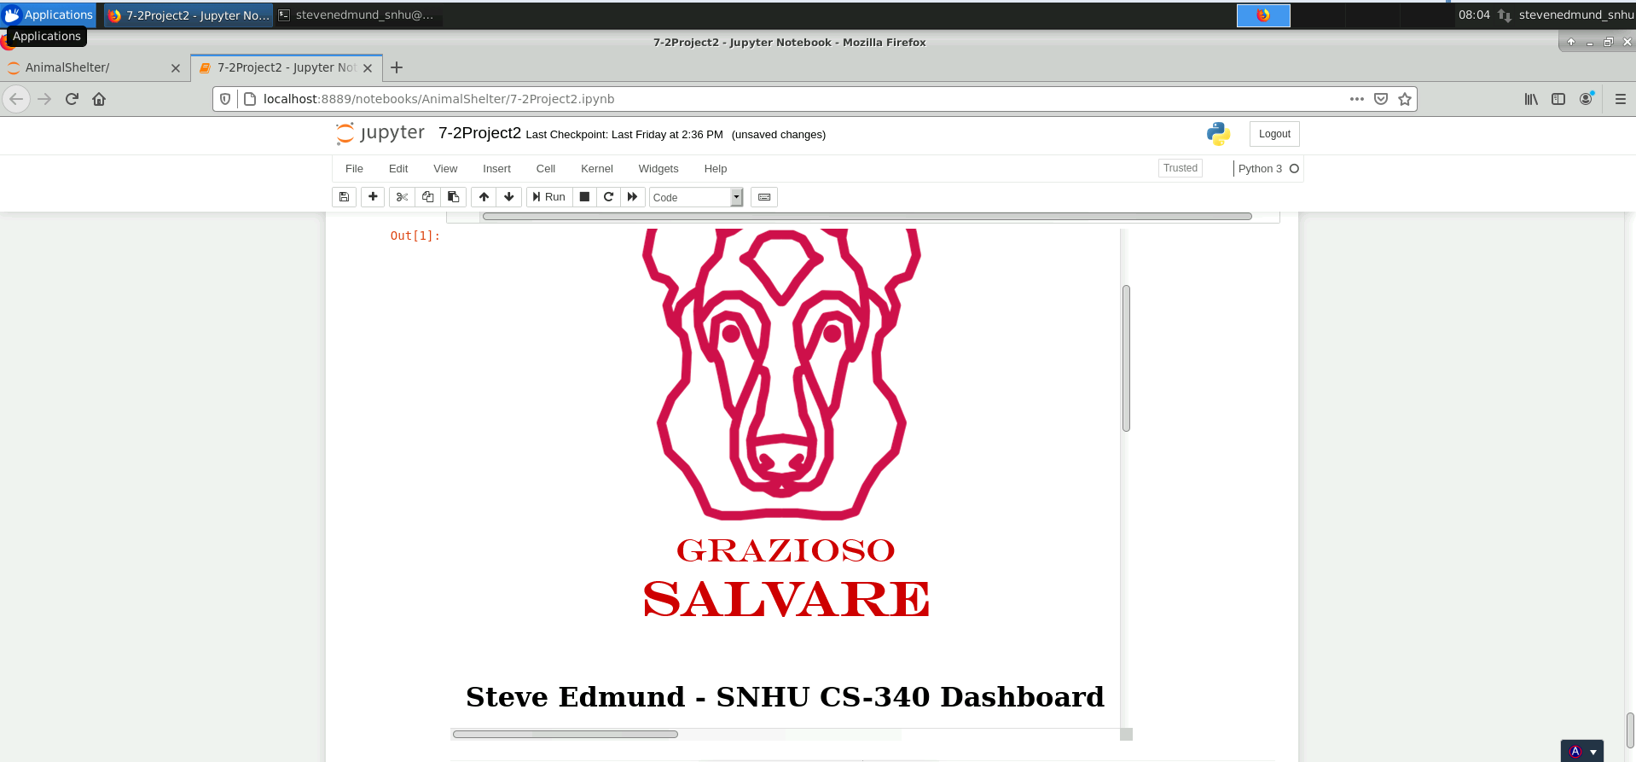

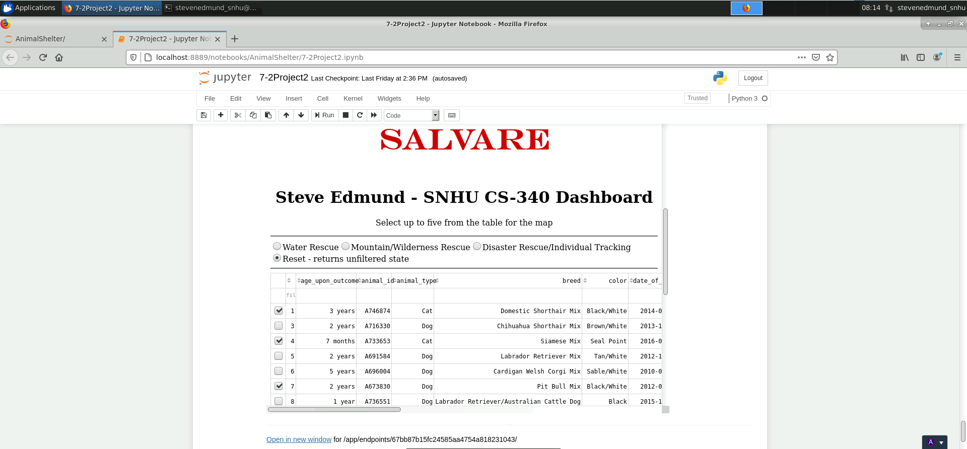

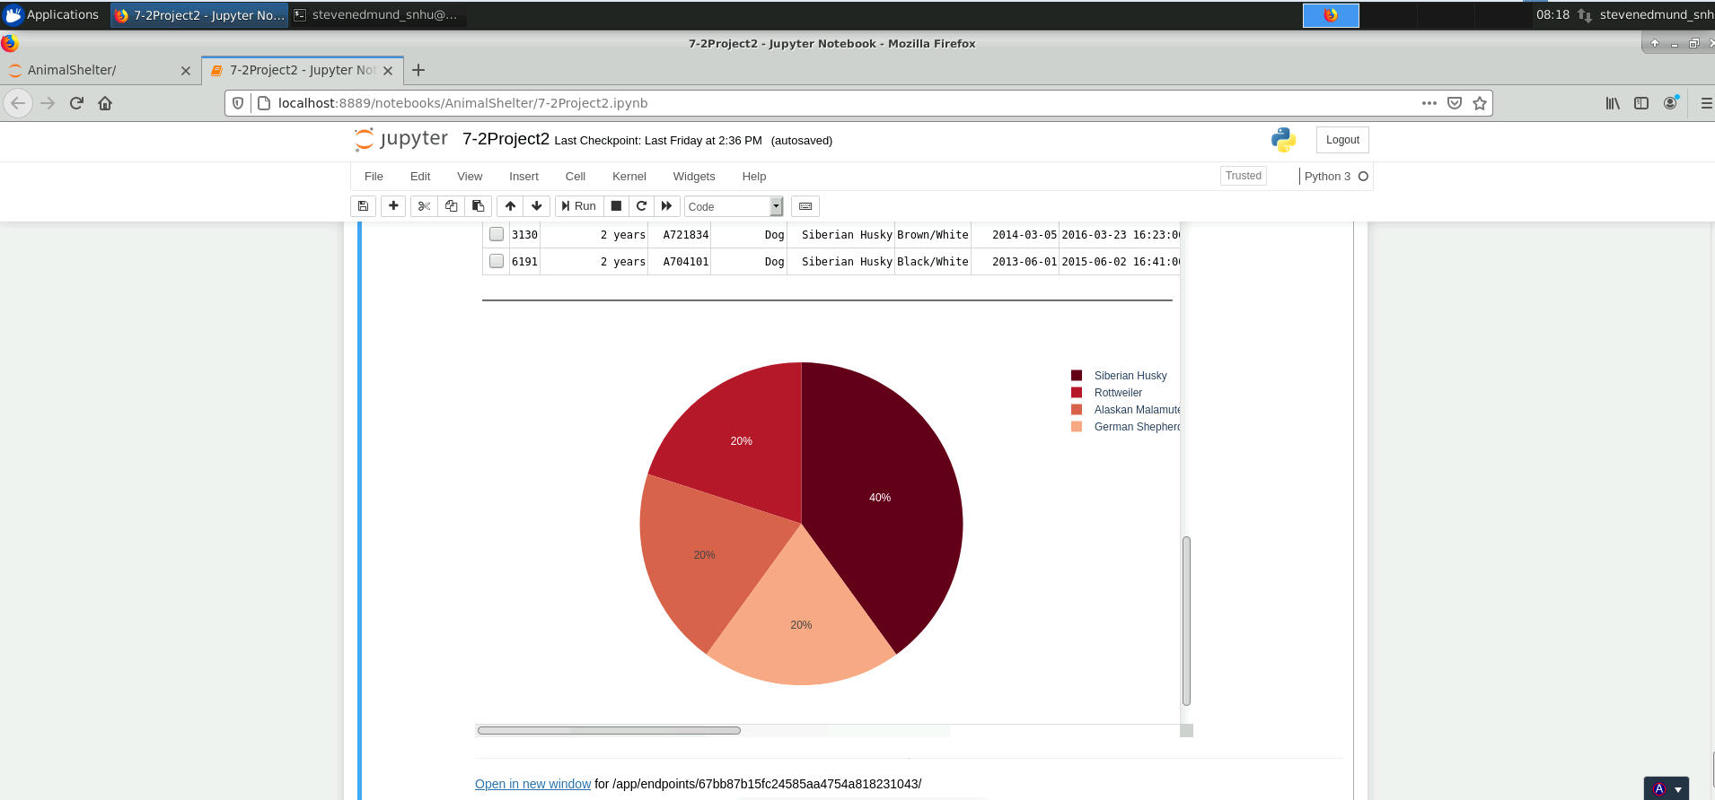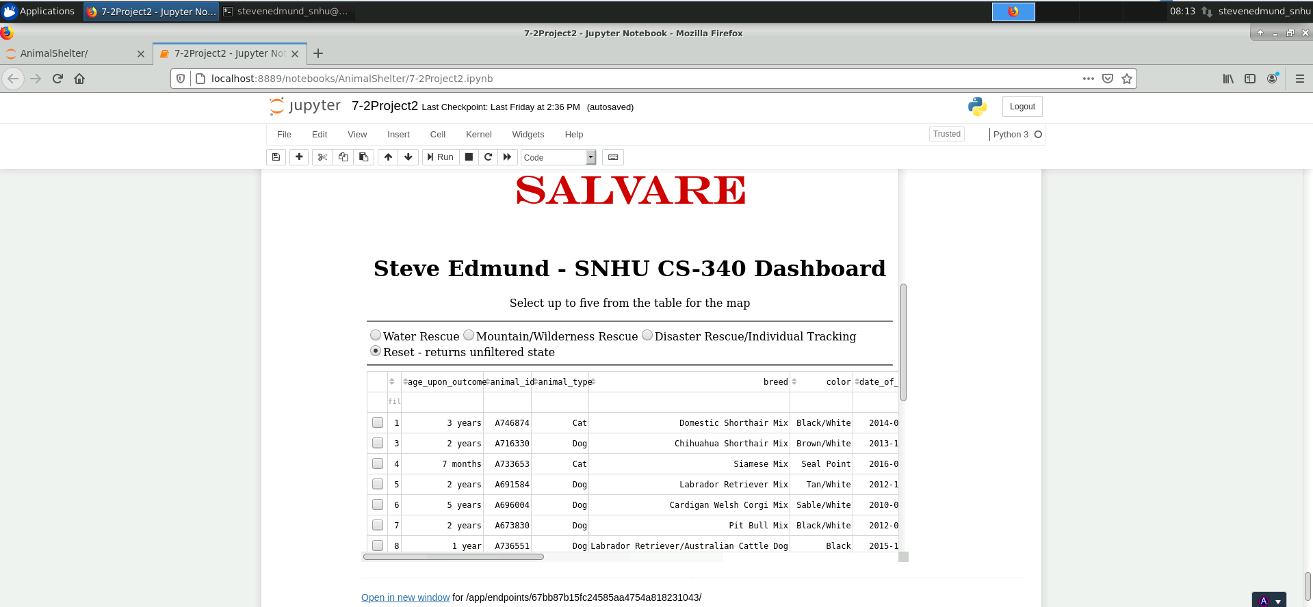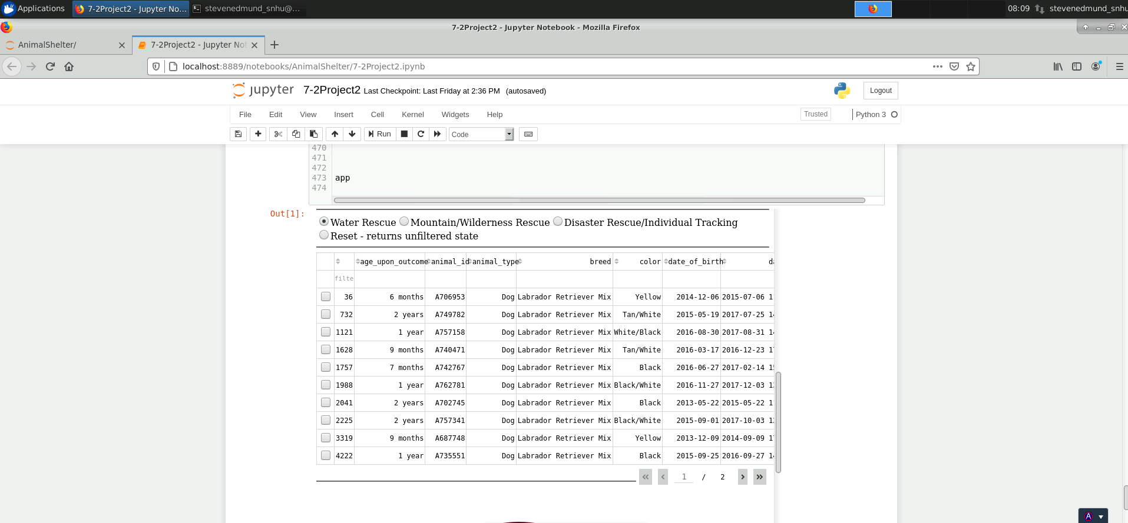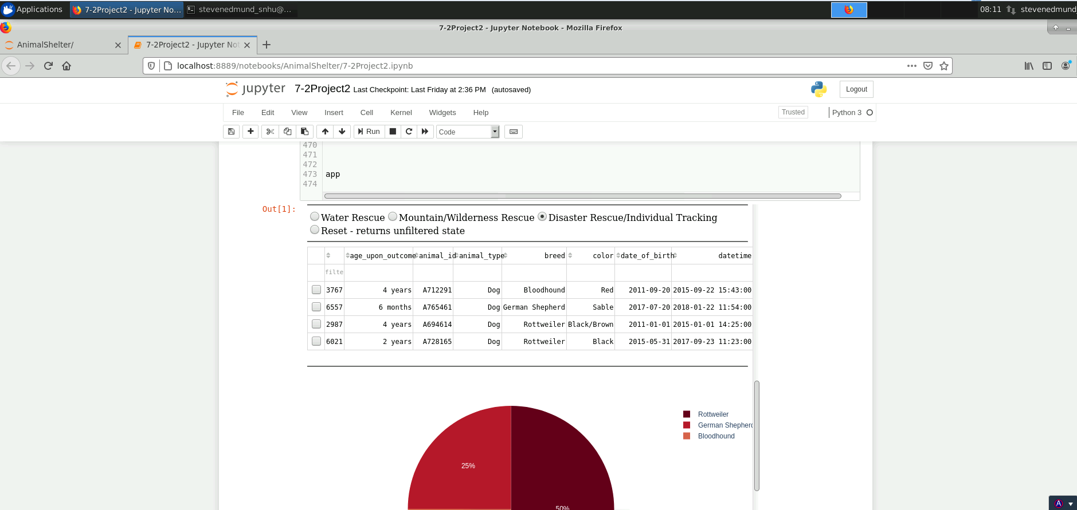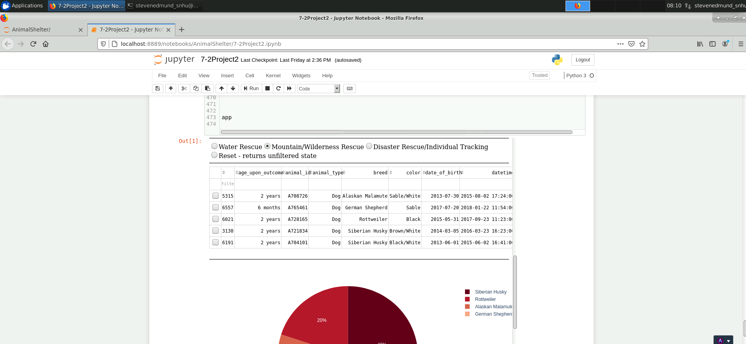

### Challenges

I faced several challenges throughout the creation of this application. Getting up to speed on Python and its syntax was probably the most challenging. Getting everything to work as was expected took a lot of mistakes and time. The requirement to have screenshots with the Grazioso logo with the table, map and pie chart all together was not possible on my small screen. I tried different methods and asked around about how I might be able to accomplish that, however, I could not find a way.

## Contact

Steve Edmund

[steven.edmund@snhu.edu](mailto:steven.edmund@snhu.edu?subject=4-1%20Milestone)